**Q.1 Why Tableau? How does Tableau compare to other BI tools?**

* Tableau is user-friendly interface, powerful data visualization capabilities, and ability to connect with various data sources.
* Compared to other BI tools, it's particularly strong in data exploration and visualization. allowing users to create complex graphs and charts with ease.
* it has speed and flexibility in handling large datasets.

**Q.2 What data sources can you connect to? How do you connect to them?**

* There to various data sources like SQL databases, cloud databases, Excel files, and web data connectors.
* I can upload data files directly to this environment. I can then access these files using Python to perform data analysis. Common file formats I can analyse include CSV, Excel, JSON, and plain text files.

**Q.3 What are the join types in Tableau?**

* The join types in Tableau are Inner Join, Left Join, Right Join, and Full Outer Join. These determine how rows from connected tables are combined based on common columns.

**Q.4 How to join data in Tableau?**

1. In Tableau, you join data by dragging tables into the data source panel and then specifying the type of join and the columns to join on.
2. Tableau visually represents the join and allows you to adjust it as needed.

**Q.5 What is the difference between joining and blending?**

* Joining combines data from different tables into a single table based on a common column,
* Blending combines data from separate data sources, allowing them to remain in separate tables and only merging the data at the visualization level based on a common dimension.

**Q.6 What is the difference between a live and an extract?**

* A live connection data directly from the source in real-time where we used internal connector.
* extract is a snapshot of the data taken at a specific point in time, stored locally in Tableau to allow for offline analysis.

**Q.7 What is a dimension vs. a measure?**

* Dimensions are qualitative values used to categorize, segment, and reveal the details in the data (i.e. Name, dates, Product),
* Measures are quantitative values that can be measured, aggregated, or used for mathematical operations (like sales, profits, or counts).

**Q.8 What is a discrete vs. a continuous value?**

* Discrete values are distinct and separate and individual items (e.g. order numbers, cities).
* Continuous values are numeric and can be measured on a continuous scale (e.g. temperature, time, revenue).

**Q.9 What is the Order of Operations?**

In Tableau, the Order of Operations refers to the sequence in which filters and calculations are applied to the data. This includes extract filters, data source filters, context filters, dimension filters, measure filters, and table calculations.

**Q.10 What are parameters, sets, and groups?**

* **Parameters**: Dynamic values that users can select to filter or control data visualization.
* **Sets**: Custom conditions to group data based on specific criteria.
* **Groups**: Manual categorization of data points that combine values into higher-level categories.

**Q.11 What is a calculated field?**

A calculated field allows you to create new data from existing data using mathematical, logical, or text functions in Tableau.

**Q.12 What is a dual axis?**

A dual axis allows you to overlay two different measures on the same chart, with two Y-axes on the left and right, enabling comparison of different but related data trends.

**Q.13 What are LOD (Level of Detail) expressions?**

LOD expressions provide a way to compute aggregations that are not at the level of detail of the visualization. They allow specifying the level at which you want to aggregate or calculate data, independent of the view's current granularity.

**Q.14 What are actions?**

Actions in Tableau are interactive elements that create a dynamic and interactive experience, such as filtering data, highlighting related information, or navigating between sheets/dashboards when the user interacts with visualizations.

**Q.15 How do you restrict access to the data?**

Access can be restricted through –

* User filters,
* Setting permissions on data sources,
* Row Level Security (RLS) to control which user can view data based on their credentials.

**Q.16 How do you increase the performance of a slow workbook?**

To enhance performance:

1. Optimize extracts.
2. Reduce the number of filters and calculations.
3. Efficient design of your workbook and data model.

**Q.17 Build a chart showing the top five and bottom five sales by customer?**

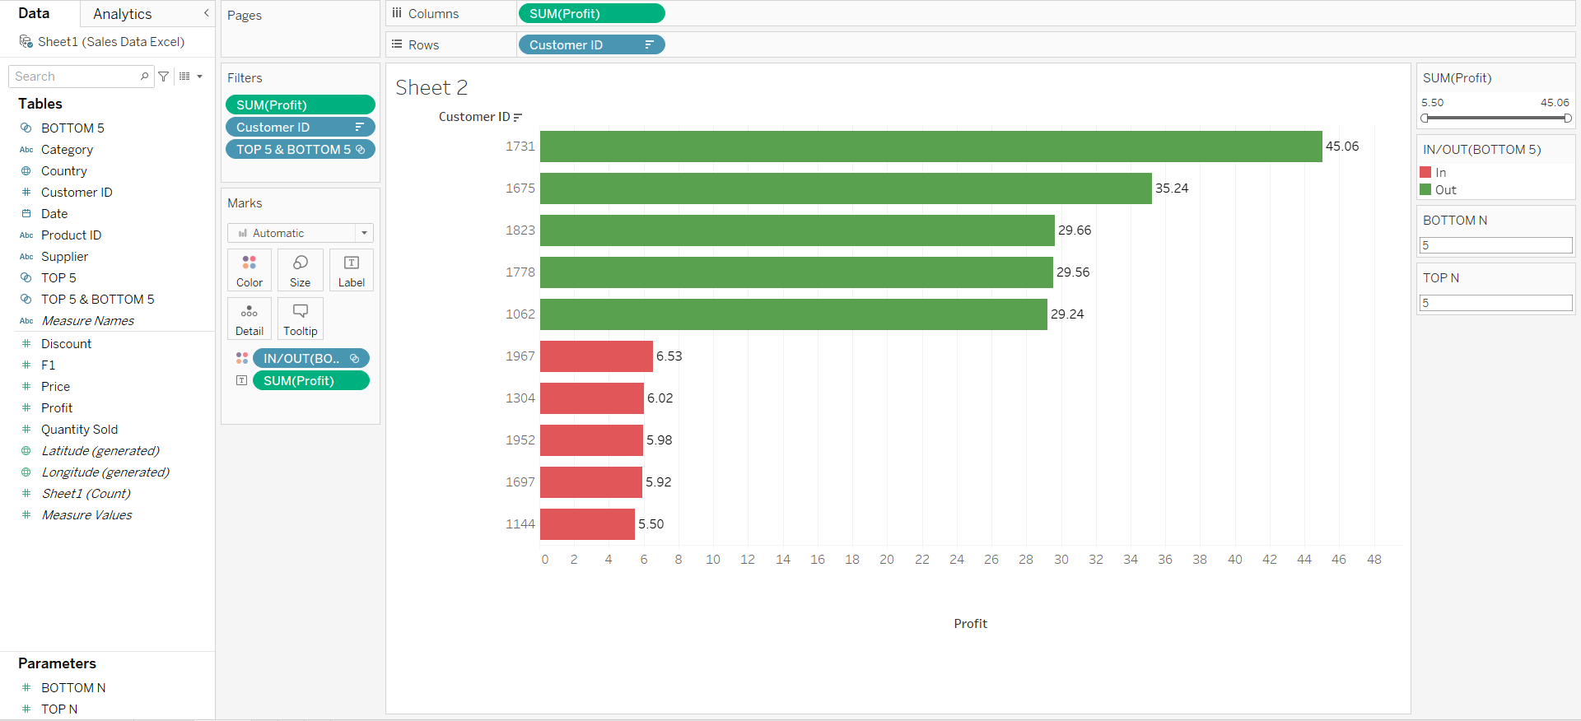

**Q.18 Find the state with the lowest profit ratio?**

To Calculate Profit Ratio, we will create Calculated Field

**Profit Ratio = SUM([Profit])/SUM ([Quantity Sold])**

